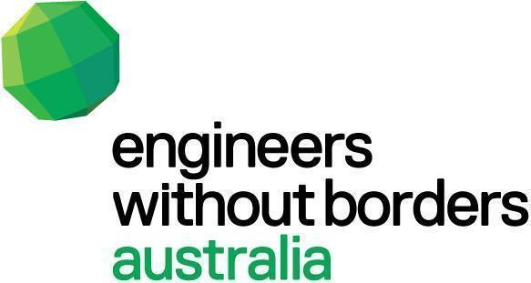

Position Details

Job Title: | Water Engineering Mentor  (Technical Volunteer)
Role type: | Full-time voluntary role based in EWB’s Cambodia Office.
Duration: | 12-18 months.
Location: | Phnom Penh, Cambodia
Additional: | Candidates will be expected to attend Training in Melbourne later in the year (date TBC)
Closing date | Monday 23rd May at 5pm. Applications will be reviewed on a rolling basis.

Context
About EWB Australia
Engineers Without Borders Australia (EWB) is a humanitarian development NGO with a National Office and staff team located in Melbourne.

EWB works within Australia and overseas to improve the knowledge and physical resources of people in need via grassroots engineering programs, capacity development and sector leadership. Our international program spans Cambodia, Timor-Leste and Vanuatu.

Established in Australia in 2003, EWB has three major focus areas:

1. developing technology to alleviate poverty and accelerate inclusive sustainable
development in Australia and overseas;
2. redefining engineering as a profession providing stewardship and leadership for a
more equitable and sustainable world and;
3. inspiring and mobilising a global community who believe in a world where
technology benefits all.

At EWB, we strongly believe that every engineer can be a change agent for a socially just and sustainable world. This belief drives EWB to lead a movement of like-minded individuals and companies working together to ensure technology is developed to make the world a better place for all.

Our Field Professional Program

EWB Australia engages professionals from a range of fields (engineering, infrastructure development, technology development, education, business etc.) to support effective and appropriate outcomes with our partners and communities. EWB partners with Australian Volunteers International with our volunteers supported through their Australian Volunteer Program (AVP), funded by DFAT. This partnership enhances EWB’s International Program offerings and provides our engineering field professionals with additional support during their in-country deployments and remote assignments.

Our Cambodia Program

EWB Australia’s mission is to redefine the purpose and impact of engineering practice as a critical enabler of sustainable development. The EWB WASH Program in Cambodia aims to improve people’s health and well-being through addressing challenges faced by communities living in hard to reach or challenging environments and their ability to access safe, hygienic and appropriate technological water and sanitation technology solutions.

Role purpose

To support EWB Australia’s Cambodia office to plan, deliver and monitor projects within its WASH Program and increase the technical capacity of EWB’s engineering staff and community partners in designing, implementing and evaluating WASH infrastructure for challenging environments.

Key Responsibilities & Selection Criteria

Key Responsibilities

- Assist in the design, planning, implementation, monitoring and evaluation of EWB’s WASH infrastructure solutions for rural communities.
- Support managing relationships with local partner organisations and government agencies. Help to strengthen collaboration and knowledge-sharing in the Cambodian WASH sector.
- Support a range of technical activities including: water utility assessments, preparing utility upgrades, designing rural water management schemes, prototyping, compiling bills of quantity, and writing technical reports for tenders and internal monitoring and evaluation purposes.
- Support water entrepreneurship through business feasibility studies and business plans for local WASH practitioners.
- Lead the design of a biosand filter for schools and a filter for water-bottles, supporting all aspects of project delivery.

- Check calculations, review input data, improve hydraulic grade-lines, supervise contractors to improve water system construction quality with checklists and quality assurance tools. Maintain correspondence with relevant partners and private water operators.

- Deliver technical capacity-building activities for EWB staff and in-country partner organisations.

- Support the coordination and management of technical staff and the organisation of technical activities.

Essential
- A degree in water engineering discipline (minimum), postgraduate degree preferred.
- Professional experience in designing, planning and maintaining indirect piped water supplies, preferably in a remote or humanitarian context.
- Knowledge of drinking water treatment processes and water quality standards.
- Ability to communicate technical content in clear, accessible written and verbal language. Strong mentoring and coaching skills.
- Ability to manage and prioritise work without close supervision, and to work collaboratively across multiple EWB teams.
- Ability to work with a diverse range of stakeholders of varied cultural and linguistic backgrounds.

Desirable
- Experience in project management and/or evaluation.
- Experience in the Not-for-Profit and/or humanitarian development sector.
- Knowledge and awareness of Behaviour Change Communication, Sanitation Marketing and Community Led Total Sanitation (CLTS) techniques

- Knowledge or experience WASH sector capacity building guideline/manual/training materials

Conditions
Australian Volunteer Program (AVP)
This assignment can only be offered to applications from Australian and New Zealand citizens and permanent residents. After being onboarded with EWB, it will require the volunteer to undergo the Australian Volunteers Program screening and onboarding process to receive additional monthly allowances and support in-country.

Time commitment
This assignment is a minimum 12 month full-time in-country position with the possibility of extension for the right candidate.

Travel
Overseas travel to Cambodia will be required.

Leave
All volunteers are entitled to 20 days leave per 12 months, unless otherwise advised. Same terms and conditions as local colleagues apply, including national holidays.

How do I apply?

Please submit your application via this online form. You will need to include your CV and respond to the registration questions. Applications will be reviewed as received, so please apply as soon as possible. Final candidates are expected to attend Training to be held in Melbourne (date TBC).

If you have any questions about the position, please email h.clark@ewb.org.au

Engineers Without Borders Australia:
- Actively encourages Aboriginal and Torres Strait Islander People to apply.
- Celebrates diversity and supports an inclusive workplace. Please contact us to discuss any personal assistance required to complete this application.
EWB Australia adheres to statutory laws in Australia and foreign countries regarding child exploitation, child pornography and the abuse of children. We are committed to the protection of children from all forms of harm. You will be required to sign a Child Protection Code of Conduct and provide a Working with Children Check and/or a Federal Police check prior to commencement.

